Originator:
Name | Job Title | Signature | Date
Andrew Mason | Chief Technology Officer
Approvals:
Name | Job Title | Signature | Date
Nancy Rizzo | Founder and CEO
Mike Stowell | V.P of Operations
Brian Tompson | Software Engineer
Andrea Miller | Quality Assurance Manager

- Purpose
The purpose of this document is to fully describe how the Clinical Trial Web-form version 5.0 was implemented.
- Scope
This document describes all the options available within the web-form and can be used for reference by the implementer/site creator.
- Definitions
Salt | A long string kept in a secret location used for prepending to passwords which makes them harder to guess by an attacker.
Hash | An algorithm that transforms a plain text password in to a string of seemingly random letters, but given then exact same input will produce the exact same output with a very small chance of collision.
Plain text | Text that has not been hashed or encrypted.
Collision | When two different inputs product the same output using a hashing algorithm.
ASP | A Microsoft technology used to develop this web-form. Further documentation can be found on the Microsoft website.

- Specification
Note: the following 4.x section corresponds to the 3.x points states in the Requirements document.
  - General
    - Users authenticate by visiting the Login page and entering their username assigned by an administrator and the password they entering during the password reset process. The password reset process can be initiated by clicking the Forgot password? Link and following the instructions. The user enteres the e-mail address associated with their username (in some cases this may be the same), and clicking the link sent to their e-mail.
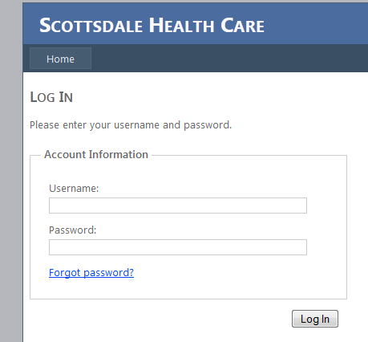
    - All usernames are unique; passwords are salted and hashed using the SHA-512 algorithm for security. This makes the password unique and irreversible when it is stored even if the user enters the same password as another user. User accounts are managed by the Site Creation SOP listed in the references.
    - A dialog is displayed after 20 minutes that redirects the users to the Login page. If the JavaScript fails, the user will be redirected the next time they try to view a page. Multiple pages can be open at the same time and only one page has to receive a click event to reset the logout timer.
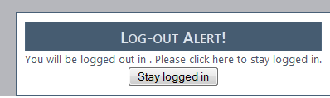
    - A user can log out using ASPs default authentication mechanism.

    - The database version is MS SQL 2008, LLBLGen is compatible with 2005 and later.
    - HTTPS can be forced using the IIS7 URL Rewrite module and setting all requests for forcefully redirect unencrypted connections to HTTPS. If this setting is not set, the web-form will be displayed over HTTP.
    - Every change to the database is recorded in the audit table. The audit entries can be viewed using a link provided by the site administrator, with the exception where auditing access has been requested in the web-form requirements such as section 3.5, Adverse Events.
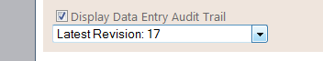
      - This information can be found using the data field key and locating the audit entry for when the subject data was entered or changed previous to the current audit record. This conforms to 21 CFR Part 11.10 paragraph (e).
      - The audit table records the old and new value, the user who made the change, and the time. Auditing occurs independent from all written source code. This conforms to 21 CFR Part 11.10 paragraph (e).
    - Subject IDs are unique and generated by incrementing from the number 1 to the first available subject ID. They are displayed at the top to the user for each site option.
    - The following roles have been implemented for each page and adding a new subject; a user can have any number of specified in the web.config file under the application setting “roles”. The roles are comma delimited. Specifying the text “subjectsearch” will allow access to the Search page. Specifying the text “export” and “viewreport” will allow access to the Export page and Report page consecutively. Specifying the text “savedata” will allow the user the global ability to submit changes to the page unless a ReadOnly dependency described below is used to disallow saving capability.
    - Functionality can be changed by modifying the database or web.config file. The config settings that can be set are Title and Identifier. Identifier specifies the format for subject IDs including the characters that do not change such as EPIC001 in the full ID EPIC001-01-001. The title can be set to indicate to the user which site they are currently accessing. Controls can be customized as described below and the translation library can also be customized as described below. The fromEmail variable is used for sending debug information and can be customized to indicate what site the email originated from. The debugEmail variable can be set to an email address for where to send fatal errors within the system. The roles variable is used to add peripheral roles that can be referred to by controls in the site configuration. searchColumns sets the default fields to display on the Search page. reportFields sets the default fields to display on the Report page. The previous two options are separated by a comma.
    - Date and time the subject was entered in to the system is displayed as a default column on the Search page. This is the time of the first audit entry. The first audit entry is created when a new subject is added and saved for the first time. This is per subject.
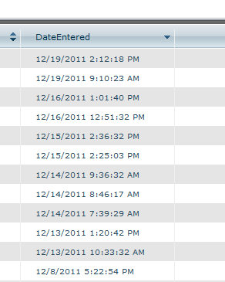
    - The permissions have been implemented as specified in 3.1.9. The read-only permission is a lack of the edit-save data permission.
    - Translations for the entire site can be done by replacing the text resource file.
    - This is implemented as a functionality of the Numeric validator described below.
    - This is default functionality of the browser when using a standard HTML select control.
    - This is a functionality of the Date validator described below. The date validator is applied to every date field in the entire system.
      - This is described in the Date validator below.
      - This is described in the Date validator below.
    - This is implemented in the Time control described below.
    - The Save button saves the data and leaves the user on the current page. The Save and Close button returns the user to the Main Menu after saving the data. When Save is clicked, all the fields on the current page are checked for proper input. The user must correct the red boxed fields in order to save the data. The same thing happens for the Save and Close button, with the addition of redirecting the user if all of the data is entered properly. If the user tries to leave the page without clicking save, a prompt appears.
    - This is implemented as specified. The static part of the subject ID is set in the web.config file. The logic for incrementing the subject IDs is contained within the Identifier control. This control checks the database for an existing subject ID; it also displays the next IDs before the location is chosen making the ID predictable for marking on paper forms.
      - The prefix can be set in the web.config file using the instructions defined in the Site Creation SOP.
      - The options for site ID is specified in the Location control in the database.
      - The numeric format for subject ID is specified in the web.config file using the instructions in the Site Creation SOP.
      - This requirement uses various controls that are described below.
      - The subject ID is displayed for each location until the location is selected and saved, then just the current subject ID is displayed. Placeholders for Date of Birth, Initials, and Gender are displayed until the demographics section is completed.
    - Subject initials are entered on the Demographics page either two or three letters are accepted:
    - The current page is highlighted in the menu.
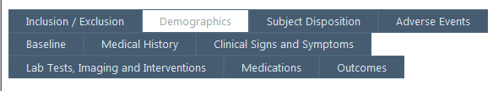
    - The data entry complete checkbox is on the Outcomes page. When the user checks the data entry complete box, text is shown indicating the most recent user to check the box. The checked box is displayed below with a label displaying the username and date for when it was last checked and saved. If the checkbox state is changed the user must re-enter their password to serve as their electronic signature.
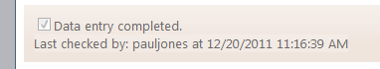
    - The statement of confirmation of completion is available to the PI permission set for a particular user. When the state of this checkbox is changed the user is prompted to re-enter their password to server as their electronic signature. If the user does not have the PI permissions, this checkbox is greyed out.
    - If the user does not have the monitor role, the Monitor complete checkbox on each page is disabled. When monitoring is checked, all other controls are disabled using the {ReadOnly} option in dependencies. When the checkbox is changed the user is prompted for their password to serve as their electronic signature. Each section is configured to be disabled when this option is checked. The options are displayed below:
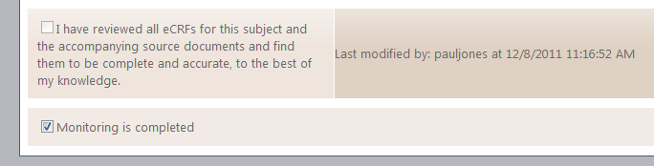
    - Subjects that have been entered in to the system can be edited by double-clicking a record in the Search results to open that subject.
    - The version is displayed on every page:

    - A list of subjects who were withdrawn can be viewed on the Search page by selecting the filter options, or using a link provided by the administrator.
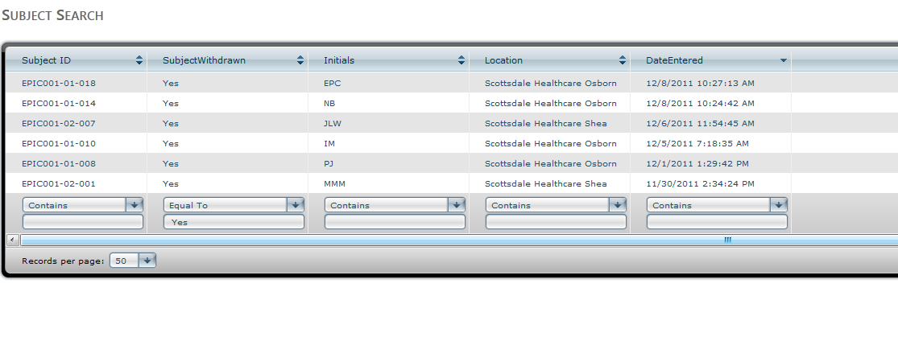
    - A separate URL for each site can be specified using the Site Creation SOP.
    - A lockout mechanism has been implemented to prevent too many guesses for a particular username. If the same IP address guesses the incorrect password for the same username 3 times in a row, they are locked out for 30 minutes. This prevents unauthorized users from guessing a password using brute force and makes the form compliant with 21 CFR Part 11.300 paragraph (d). If a login is invalid 3 times, an e-mail is sent to the system administrator for corrective action to be taken.

  - Inclusion / Exclusion
The specification for each control will be listed in order of appears, right-to-left, top-down. If the requirement and intention of a control is the same as a previously stated specification and the same configuration and logic is used on the control, a reference to the bullet point will be used. In order to reference each control the section title, the prompting question and a brief description of the controls placement is used.
    - This corresponds to requirement 3.2.1. “All fields are required” is implemented using the Default Validator. The default validator requires that a value be entered for every field.
    - This corresponds to requirement 3.2.2. The subject ID is automatically assigned when the user clicks “Save” on the first visited page. The subject ID is incremental as specified in requirement 3.1.19. The subject ID and other information specified below is displayed in the Global section at the top of the page. This section is displayed on every page.
    - The Inclusion / Exclusion page uses a Page control and contains 3 sections.
    - The first section “Informed consent form” uses a section control. The first “row” is a header that is a part of the section control.
    - The second row “Informed Consent Form must be signed…” has been included in the output to provide instructions to the users despite the note “***Note: For the requirements listed in sections 3.2-3.11, italicized text indicates requirement notes specific to that section. Non-italicized text is actual verbiage that should be used” specified in the requirements.
    - The third row uses a Label control which just displays the text “Is informed consent process completed, with Informed Consent Form signed?”
    - The instructional text “When no is selected” is implemented using a Normal dependency control. This control looks at selected values and makes controls such as warning notices in this case visible or invisible while the user interacts with the page. In this case, the label “the subject may not participate in the study” is displayed when the user selects “No”.
    - The third row, the control on the right. All controls that require a user to select just 1 option uses a Radio control, unless otherwise specified in this document or by italicized text.
    - Date and time appears when yes is selected using a Normal dependency describes in 4.2.5.
    - The fourth row uses a Label, Radio, and normal dependency controls.
    - The instruction “All questions in this section must be answered “Yes”” appears to the user on the form.
    - The requirement “If “No” is checked for any subject for exclusion criteria, a reminder appears saying,” is implemented using a Normal dependency described in 4.2.5
    - Exclusion criteria – row 5 – “Dropdown options (1 or more selections required)”. When more than one option can be selected, a Checkbox control is used.
    - Exclusion criteria – row 5 – For blank lines, such as “Other ______” a Text control is used to allow text to be entered without restriction.
    - Exclusion criteria – row 5 - Date administered: _ _ / _ _ _ / _ _ _ _. All date fields use the Date control. The date control accepts an option day and month unless it is specified “Full date required”. All date use the format described in part 4.1.16.
    - Exlusion criteria – the last row uses the magic phrase “Only one is required” and therefore uses a Radio control.
  - Demographics
    - All fields are required by the Default validator.
    - When the subject information is saved, the {Gender} and like fields are replaced with their selected value.
    - Subject Initials – A RegExp validator is used to ensure this field contains two or three letters that serve as initials.
    - Date of birth – Uses the Age validator to compare the date of birth entered and the date the subject was entered in to the system.
  - Subject Disposition
    - Device serial number – multiple lines (____) are specified which indicates the use of a Text control, since there are many lines; the {Multiline} option is used. When “Not applicable” is checked, the {Disable} dependency that is used grays out the textbox and disables input. The textbox will not be saved if it is disabled.
    - “Is full scanning procedure completed?” – Uses the DateCompare control to compare the date entered with the date scanned. If the subject enters a date before the date of consent a warning message is displayed.
    - “Is full scanning procedure completed?” – Uses a radio control for No, Yes. Uses a Date control for date and a Time control for collecting time.
    - “If yes, why was the subject withdrawn? (Select the primary reason)” uses a Select control (aka dropdown).
    - “Is the image quality satisfactory” - Name of individual performing assessment: - Uses a Label control that displays the last user to change the status of the of the Radio control No, Yes.
    - The “Other:” options and withdrawn boxes use a Text control.
    - Notes – Is disabled if N/A is checked.
  - Adverse Events
    - Adverse Event ID is generated based on the index of the adverse event entry. When “Reported previously?” is answered Yes, the user is required to select an existing event as the “parent” of the previously reported event. This uses the SelectIndex control. When an event is removed, that index must be re-selected.
    - Event code – Select control
    - Other (specify): ____ - Uses a Text control and a Normal dependency to make it visible when Other is selected from Event Code.
    - Event occurred uses a Radio control.
    - “If results in death” – Uses a Date control and a Normal dependency to be displayed only when “Results in death” is checked for the question “If serious, what was the reason?”
    - Reviewed by principle investigator uses a Login control to prompt for the password when the check status changes.
    - An Email control is placed on this page to send an e-mail when “Did the subject experience and adverse event?” is selected as Yes and saved.
    - “Display audit trail” uses an Audit control which when displayed shows a list of all the times the user clicked the Save button.
  - Baseline
    - Hospital status – Time of arrival to ED – Date control for recording date using the {Full} option, Time control for recording time. When Unknown is checked the Time is disabled, greyed out, and not saved.
    - Pre-testing characteristics – When Yes is selected for any of the following questions, a Normal dependency is used to make the Text control to the right visible and input is required.
    - Lifestyle – How much do you smoke? – A Text control is used for collecting a number. A Numeric validator is used to verifying that the data entered is a number. Two Select controls are used to unit and timespan.
    - Lifestyle - How many drinks do you have per week? – A Text control is used with a Numeric validator.
    - Cardiovascular health – Do you take nitroglycerin? – A Repeater control is used to allow the user to enter many dosages and corresponding dates/times.
    - Current and Historic Cardiovascular Diseases – A Repeater control is used to repeat the same diagnosis table for each type of disease. This control uses the Repeater in a specific mode, which does not allow diagnoses to be added or removed, just appear in the same format for each.
    - The diagnosis section uses a Diagnosis validator.
  - Medical History
    - The same Repeater control in 4.6.6 is used to repeat the date and times for each diagnosis. Each diagnosis is made up of a Date, Time, and Checkbox controls.
    - Chronic renal failure – The {Insert} option is used in conjunction with the Diagnosis controls to insert the option for stage.
    - Surgical history – Uses a repeater control to allow for adding of many surgeries. Uses a Normal dependency when No is selected the {Disable} option causes the surgery Repeater control to be disabled and not save.
    - The diagnosis section uses a Diagnosis validator.
  - Clinical Signs and Symptoms
    - Select all symptoms that apply – uses a Checkbox control.
    - Other (specify): - Uses a Text control inside a Repeater control to allow the user to enter more symptoms.
  - Lab Tests and Imaging, and Interventions
    - The sections specified in the requirements where Admission/Initial and “Most Recent” forms use a Repeater control with the {MAX} option to specify that only 1 or 2 forms can be added/removed/cleared.
    - All numeric fields use the Text control with the Numeric validator.
  - Medications
    - A Repeater control is used to allow for repeating of medications.
    - The child controls of the Medications repeater include the Type selection which is a Checbox control.
    - An AjaxText control is used for the Medication name. This control retrieves a list of medications from the server as you type.
  - Outcomes
    - A Repeater control is used for allowing the user to list many outcomes.

  - Search
    - The default columns are implemented as listed.
    - Subjects can be found by subject ID by clicking filter at the bottom of the grid and then typing in the subject ID under the subject ID column and clicking Apply filter.
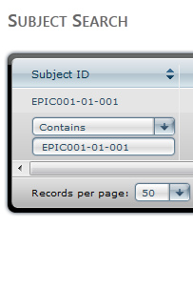
    - Columns can be sorted by clicking on the heading.
    - Subjects can be filtered by setting the filter options at the bottom of the grid.
    - Other fields can be viewed on the search page by selecting the count on the Report page. You can also type &Control<i>=<field> in to the URL where <i> is a numeric index between 1 and 100 and <field> is the name of a field. Controls inside repeaters will not work.
    - Filters can be added in the link by entering Filter<i>=<value> in to the URL where <i> is the index of the control you want to filter, and <value> is the text value of the filter so that only subjects with entered value will be shown.
    - Sorting can be done by adding Sort<i>=Asc|Desc to the URL. Or by clicking a column header.
    - Field headings can be set by specifying the title in the language file using the convention Field_<field name> where <field name> is the name of the field defined in the database and displayed in the table.
  - Report
    - A scan date range can be entered in the report as a filter.
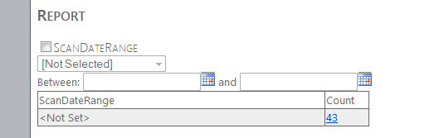
    - All fields support filtering by checking the box and making a selection or entering the value of the subjects you want to filter by, just like on the search page. Filters can be set in the URL just like described in 3.8.6; however the user must enter the actual value of the control rather than search criteria.
    - More fields can be added to the report using the same method described in 3.8.5.
    - Field headings can be set using the same method specified in 3.12.8.
  - Export
    - A user will have access to only Export when the user only has the “export” permission on their user account.
    - The menu item is labeled Export for simplicity.

    - A .csv file is exported when the delimiter is set to a comma; otherwise it is exported as .txt.
    - A log is shown when a user clicks view or export.

    - The Export Log is displayed on the page and can be viewed by clicking on the Export Log header.

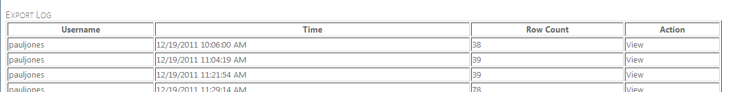
    - All data can be exported by checking the boxes next to all the pages.
    - The mapping for the data can be seen in the field specification column:
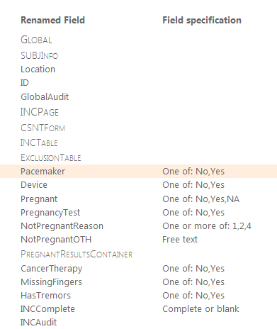
    - The export function uses the same protocol as the rest of the site, which will be forced to use HTTPs.
    - Fields can be relabeled to abbreviated form as displayed in the renamed field column. This is specified in the same format as described below.
    - The annotated fields are listed next to each original field name and checkbox.
    - The delimiter can be set in web.config by replacing the ASCII decimal for the value <add key="Delimiter" value="
    - Characters can be replaced in every data field by specifying the replacements in the web.config file, in the format of “<match>=<replace>,<match>=<replace>” where <match> is a string or numeric ASCII character and <replace> is a string or numeric ASCII value.
- Control Reference
These controls are “modular” objects that can be used to provide the specified functionality throughout the site. These descriptions are referenced throughout the Specification.
  - Structural Controls
Control Name | Description | Options
Page | The page control is the top level container for the other controls. This is the only control that affects the menu options displayed above. The menu items will be displayed in the order specific by the Index property. | The page title can be set in the translation resource file.
Section | This control creates a basic grid for holding other controls. This control contains only rows of other controls. The index of this control will determine where the control is on the page. | The title can be set for the section.
Row | This control fits in to a Section control. The index determines what order the row is in the table. It places child controls horizontally ordered by the Index. | Rows can be hidden using properties set in the dependencies table. This is an easy way to hide or display many controls at once.
Container | A container control is only used to hold other controls for the purpose of hiding or displaying certain elements using dependencies described below. | This control can be hidden, and can contain a label.
Label | The label control is for displaying text in certain areas on the form. | The label text can be specified in the language file. The label text is also evaluated after load. The format for displaying values for current controls is {[<control>].<property>}, where <control> is the name of a control and <property> is the name of a property, such as “Value” without the quotes. The possibilities are endless!
Repeater | The repeater control takes a set of controls and repeats the exact same configuration multiple times. All repeaters require at least 1 entry. The repeater can be hidden or disabled by a dependency in order for no entry to be required. | {<number>} where number is and integer can be used to limit the number of times a set of controls can be repeated. Option1,Option2,Option3,etc. will repeat the control 3 times, with no options to add or remove; this is the static mode.  The Value property is set to the current value either and integer index or the option name and Insert dependencies can use this to determine when to insert additional controls, described in detail below.

  - Data Controls
Control Name | Description | Options
Checkbox | The checkbox control displays a list of checkboxes. Any number of checkboxes can be selected. | A label can be placed above the list by defining it in the languages file. {<number>} can be used to specify a sequential list of values. Option1,Option2,Option3,etc. or 01,02,03 can be used to show a defined list of values.
Radio | The radio control displays a list of radio options. Only 1 can be chosen. | A label can be placed above the list by defining it in the languages file. {<number>} can be used to specify a sequential list of values. Option1,Option2,Option3,etc. or 01,02,03 can be used to show a defined list of values.
Text | The text control accepts any text entry that matches a number of optional validators described below. | {Multiline} can be used to specify that the text control should accept line return characters. This also makes the textbox larger to show multiple rows of characters.
Date | The date control accepts a date and displays a popup calendar. | {Full} can be set on the default validator; this will show a tooltip on the date control with the expected format.
Time | The time control has two drop-downs for select an hour and minute. | There are no options.
Select | The select control displays a drop down list. | The options should be listed in the format Option1,Option2,Option3,etc. The text for each option should be specified in the language file.
AuditHistory | The audit history control displays the record of changes made to the database. | There are no options, however, this control evaluates the label against the audit record to allow for optionally displaying the username of the audit record and date and time formats.
Login | Requires the user re-enter their password when checking the electronic signature boxes. This allows the form to comply with 21 CFR Part 11. This control only accepts a password, the currently logged in user must enter their password. | There are no additional options.

  - Special Controls
Control Name | Description | Options
Age | The age control displays the age of the person at the time of scan or first entered in to the web-form. | There are no options.
AjaxText | This control performs an AJAX request to retrieve a truncated list of medications when the user types in the medications text box. That is the only application of this control so far. | There are currently no options.
Week | The week control displays the week that the subject record was created starting from the earliest entry. | This control evaluates the options such as {ScanDate} and displays the week of the current subject relative to the earliest ScanDate value in the database.
Identifier | The Identifier control contains the logic for finding and assigning new subject IDs by checking for existing records in the database. | This control has no options; however it uses the configuration value “Identifier” to set the format of the subject IDs.
DateRange | This control displays a date range that the subject record was created between. This control is currently only used on the Report page. | This control evaluates the options such as {ScanDate} and displays whether or not the ScanDate is within the specified date range.
Email | This control sends an email when the dependencies are met. | The email addresses to send to can be listed in the options separated by semi-colons. The email body should be specified in the language file using the same value replacement format as specified for the Label control. This will be evaluated after the page is saved and the email will be sent. The subject can be specified in the language file using the name of the control appended with the word “Subject”.

  - Dependencies and User Interaction
Some controls depend on other controls for disabling or visibility. These interactions can be defined during the site creation process.
Logical Operator | Description | Options
None/Normal | This is the same as using a single AND operator with no other conditions. This is simply and indicator to the site creator that there is no other interactions that cause the dependency to pass or fail. | {Disable} will disable the field when the conditions are met.  {ReadOnly} will make the field read only, when the conditions are met. This option is evaluated server side and data cannot be saved on read only controls.  {Insert} can be used inside a Repeater control used above to augment certain controls. For example, on the Medical History page, when Diabetes is selected an option for which type of diabetes is displayed.  {<database value>} can be used to evaluate the saved value from other pages in order to disable or hide the controls on the page.  {[<control>]} can be evaluated on controls on the current page. This can also be used to check if a user has a particular role. For example, {[monitorRole].Text} with a value False is used to only enable the monitor checkbox for people assigned the monitor role.
AND | Can be combined with multiple dependencies with an AND operation, example: on the adverse events page, when a serious event occurs AND when death is a result, the time of death prompt is displayed.
OR | This can be combined with other resulting values using an OR operation. For example, on the Inclusion/Exclusion page, the warning is displayed when a subject has used lotion OR washed their hands OR any of the other options are set to Yes.

  - Page Validation
Validators are executed in the order specified by their Index.
Control Name | Description | Options
Default | The default validator requires text to be entered. The default validator is overridden for each of the data controls specified above. The default validator applies to the Text control. | {None} can be used to remove the default validation and allow for the user to save the state of the control regardless of its value.
Date | The date validator requires that a proper date is entered in the format of 01/JAN/2012. With an optional month and day. | {Full} can be used to require a full date, where month and day are not optional.
Checkbox | The checkbox validator requires that at least 1 checkbox is selected. This is also used for the Radio control, as they act the same. | There are no options.
Select | The select validator requires that a selection be made other than [Not Selected]. | There are no options.
Time | The time validator requires that a selection be made other than HH and MM. | There are no options.
Numeric | The numeric validator requires that the number entered in the text box be a valid number which allows for a decimal point. | There are no options.
RegExp | The regular expression validator compares the value of the control to the regular expression. For example, on the Medications page, the medication should accept a dosage range so it accepts a number with a decimal point and optionally an added dash followed by another number with a decimal point. | The option is used as the regular expression to match the value against.
DateCompare | This validator compares a date control on the page with a date stored in the database. | First, an operator must be specified, one of >=, <=, >, <, or =. This should be followed by {<database value>} where <database value> is the name of a field stored in the database.
Age | The age validator is currently only used to verify that the Age of the subject at the time of scan is between the ages of 18 and 85 | This is the default validator for the Age control and has no options.
Login | Validates the Login control. Requires the user to re-enter their password if the checkbox changes. This validator checked the password against the user store and fails if an incorrect password is entered and cancels the saving mechanism. | This is the default validator for the Login control.
Diagnosis | This is a special validator used to traverse the hierarchy of the Diagnosis sections on the Medical History page and the Baseline page. This control puts a red box around the section of diagnoses when a user has not selected at least 1 diagnosis or the None checkbox. | This control has no extra options.

  - Labels
Labels on fields are not evaluated, however the Label control evaluates the text specified in the language file. {<database value>} can be used to display a value from the database on another page. {[<control>].Property} can be used to display a value of a control on the current page. For example, Last checked by: {[AdverseEventsComplete].AuditStack[0].CreatedBy} is used to display the last user that checked the adverse events completed monitoring checkbox at the bottom of the adverse events page.
Controls with options have the following methods of evaluation when setting the label that corresponds to each control in the following order.
    - First, the exact control name is used, if the control is inside a repeater, the format for the label is Repeater_Option_Field. For example, to label the first medication entered, the language file would contain the value Medications_0_Medication. If the control is of type Select, Radio, or Checkbox, assignment is done with the option value appended to the field name.
    - The field name is used to find the label in the languages file.
    - The control type is used to find the label.
- Reference
IT-001.001 Clinical Trial Data Site Creation
21 CFR Part 11, Electronic Records: Electronic Signature
- Attachments
Minimum system requirements – This explains the minimum requirements to access and use the web-form effectively.

In order the use the webform:
The client computer browser must be
Internet Explorer 8,
Internet Explorer 9,
Firefox 3.6 or higher.
Javascript must be enabled.
Cookies must be enabled.

Document Revision History
Version Number: | Description of Change: | Date: | Updated by:
000 | Introduction |  | B. Cullinan

